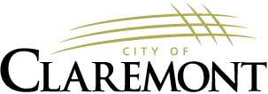
The Claremont City Council will hold a Special public meeting on Monday, June 23rd, 2025, at 5:00 p.m. in the Council Chambers of City Hall.

AGENDA

5:00 PM 1. PLEDGE OF ALLEGIANCE

5:02 PM 2. ROLL CALL

5:04 PM 3. CITY MANAGER AGREEMENT

7:00 PM 14. ADJOURNMENT

PLEASE NOTE: Claremont City Council’s next scheduled meeting will be on Wednesday, June 25, 2025, Public Hearing and Vote – 2025 Budget will be held on June 25, 2025, at 6:30 p.m. in the Council Chambers of City Hall.

